What Does a Fisher House Manager do?
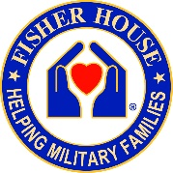
In preparation for the 2017 Friends of Fisher House Conference, four Fisher House Managers were asked to provide a list of:
1) their official job responsibilities, and
2) all the other stuff they do (i.e., what their REAL responsibilities are).

They were intentionally given a short suspense date, which means they didn’t have much time to ponder the request. Below are their unedited responses:
___________________________________________________________________________
FH Manager Blue Response
Official:
Coordinate referrals, admission, check-outs
Maintain records, policies, SOP’s, etc.
Complete work orders and coordinate with Engineering Service, Environmental Management Service and Contracted Service vendors
Manage purchase card and purchase supplies
Coordinate volunteers
Liaison with 501c3
Community Outreach/Events
Manage swipe card system
Complete reports
Give tours

Other:
Maintain landscaping (literally plant flowers, weed, trim bushes, etc)
Event planner/party planner
Housekeeper when down staff – includes cleaning the rooms, washing floors, cleaning toilets, etc.
Grocery shopping
Cook
Provide informal support to distressed families
Chaperone on outings with families
Give rides to/from the hospital (w/golf cart)
Give hugs
FH Manager Green Response
-Compassion care for 27 families nightly (Sometimes we are so emotionally exhausted at the end of the day, we don't want to "talk" even with our families-this is the most challenging part of our job)
-Guest mediator
-Reservations
-Check-in processes and check-out processes/enforcement
-Develop 3 annual budgets, stay within those budgets by making sure the appropriate expenses and deposits are going to and coming from the correct budget. Be accountable for any glaring differences.
-Rule Development and enforcement for the house (locally and as appropriate all AF FH policy compliance)
-Evictions if necessary
-Web-site and Social Media Updates/engagement
-Civilian and military media interviews and updates
-On-call 24 hours (#1 phone call in the middle of the night is a room lock out--although we get all sorts of afterhours calls everything from 'there is a squirrel in my room' to 'the fire alarm is going off') We average 2-3 call or texts each night.
-Disseminate work load for 4 housekeepers (often making multiple adjustments daily)
-Advertise, hire, train housekeepers and provide oversight to ensure quality standards (Housekeepers turn over 2-3 annually due to low pay)
-Volunteer recruitment, orientations, training, ensure quality standards and love on them so they keep coming back this includes daily volunteers as well as the meal train (3-4 meals weekly)
-Research and procure replacement items such as guest needs, furniture and linens as appropriate
-Plan and execute employee and volunteer appreciation activities
-Foster and maintain relationships with chain of command, volunteer groups, hospital discharge planners and case workers at military and civilian medical facilities, VA, donor organizations, base agencies such as HR and accounting.
-Receive donations and properly disseminate or dispose of
-Attend 2-3 monthly community briefings to share the good news of the FH with various organizations
-Attend and Implement mandatory military training such as; Government credit card use, sexual assault, suicide, hazmat, MSDS binders, HIPAA compliance, etc.
-Provide weekly, monthly and annual reports to several agencies requiring them (and in multiple formats...everyone wants a different report)
-Provide house tours as requested (making adjustments for the needs of the group such as how long of a tour they want or what they want to see...etc)
-Attend multiple meetings monthly such as: (Commanders, community donor groups, private organization)
-HR -hiring, giving raises, disciplinary actions, firing, weekly time keeping, bi-annual and annual evaluations, time off and sick leave requests and maintaining the HR documents in accordance with AF regulations
-Facility Maintenance - identifying deficiencies, scheduling the appropriate agency to do the repair, ensuring the right fund is being used to pay for the service, paying the bill and maintaining the appropriate records for auditing purposes. Sometimes, doing the repair ourselves because it is just faster and easier.
-Comply with audits and unexpected inspections
-Figuring out how to Prioritize as someone is standing at the counter demanding attention, two door bells and 3 phone lines are all ringing and....you are by yourself.......
-Take the laundry or make arrangements for the laundry to be taken to the laundry facility three times a week
-Decorate for holidays, and special events such as a guest birthday or end of treatment celebration
-Plan, train for and execute safety measures for staff and guests as we are not supported with security options other than 911. We have been stalked and have been on lock down for active shooter twice, we have had a suicide, we have had alcohol, illegal drug and hooker incidents, theft, child abuse and domestic violence in the house.
-Maintain inventory and loss prevention of guest use items and rooms, donated items and government procured items.
-Identify and facilitate base access which requires a security process and physical trip to the visitor center sometimes multiple times daily.
-Other duties as assigned: Organize, clean, repair, shovel snow, weed flower beds, grocery shop, give rides, etc.)
-Attend annual managers conference (refreshing to the soul)
FH Manager Brown Response
I provide daily/weekly & monthly reports to my Leadership.
Receive Fisher House Consults daily for guest stays.
Provide guest orientation and assist them in filling out their paper work and guest agreements. Explaining what communal living is all about shared common space etc.
Most individuals have never lived in a communal environment. Most important is safety information and what to do in an emergency or if they have an issue after hours.
Update SOPs as needed.
Provide administrative assistance to Social Work Service as needed.
Communicate daily with VA Police and (AOD) Administrator of the day about after hours procedures at Fisher House.
Sit on several committees at the VA.
Assist in other departments by sitting on hiring panels.
Provide daily/weekly/monthly tasks to grounds and housekeeping.
Meet with safety monthly to ensure there are no hazards on FH grounds.
Place work orders and make sure PM is done on house.
Coordinate monthly meals and group activities.
Inventory & Order Fisher House supplies.
Ensure staff are up to date on all VA training.
Attend all Social Work Service meetings.
Recruit, train and manage all Fisher House Volunteers.
Coordinate delivery and ensure all proper paper work is turned in for gifts in kind.
Schedule and provide Fisher House tours.
Occasionally cook some of the Fisher House meals.
Fill out proper paper work and deposit Fisher House monetary donations into the FH General Post Fund.
Schedule laundry pickup and delivery and conduct inventory.
Schedule all deliveries to include new door mats each week and water cooler.
Manage Refurbishment matrix and ensure projects are completed.
Provide Kleenex and shoulder as needed.
Dispose of spiders, snakes and bugs as needed.

Fisher House Manager Black Response
Supervisory and periodic duties:
• Supervision of two staff personnel in two different buildings plus coordination with
EMS(housekeeper) supervisor to manage one full time and one part time housekeeper
• Approves time off requests/time keeping
• Settles any personnel matters that may come up
• Provide bi-annual performance appraisals
• (as needed) work with HR on hiring; drafting position description, drafting job analysis for tasks and competencies, interview new candidates
• Oversees training requirements for staff
• Consolidates information to draft a monthly status/lodging report
• Runs yearly refurbishment report including arranging for a walk-through with FM and interior designers to assess update needs.
• Attend week long managers training
Daily duties:
• Oversees day-to-day operations of the FH and Hoptel
• Corresponds with all community groups, public affairs officials, volunteer services, Facility management, director’s office, and other areas both internal and external on any needs.
• Receives consults/referrals from hospital and arranges for appropriate lodging needs
• Directs outside calls from families requesting lodging on how to request a referral from the medical center.
• Directs medical center staff on how to enter a consult and when it is appropriate.
• Receives daily donations and oversees disbursement of donations, tracking donations and informing volunteer services of all incoming donations.
• Oversees all purchase cards expenses, approves purchases, assess needs for additional purchases.
Actual daily duties!
• First thing upon arrival; assess house for any issues, greet morning guests who are in the house, answer any questions or address any issues that are brought to my attention from the night before.
• Check status of any overnight check in’s via AOD.
• Update guest room bed board with any changes from day before
• Prepare check in packets for new referrals/current day check ins
• Complete check ins for any morning arrivals when manager is working alone
• Contact guests for next day to confirm room availability and discuss options if no rooms are available.
• Address any housekeeping issues/linen deliveries
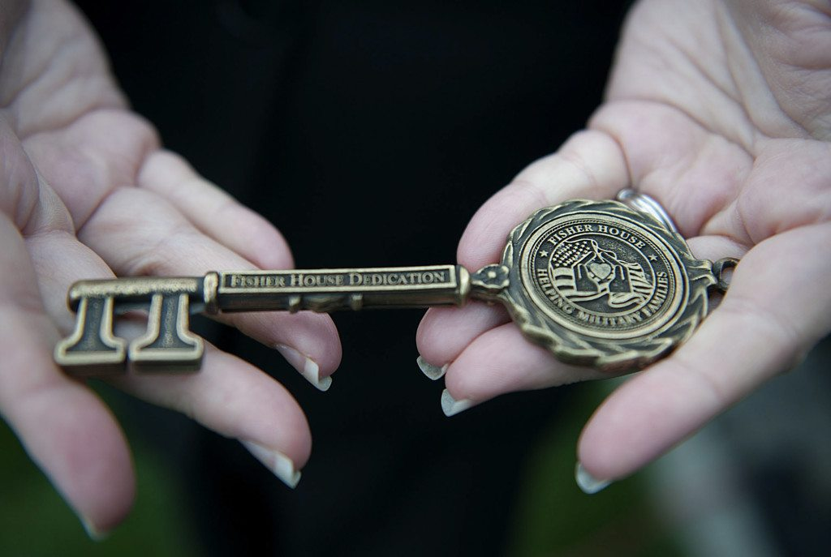
• Meet with volunteer on duty to prioritize tasks to be done
• Coordinate/attend any meetings with various areas or groups, new volunteers, staff,
• Meet with any planned or unplanned visitors and provide tour/information
• Work with director’s office, VISN program manager, Fisher House Foundation on any action items needed.
• Attend any VA mandated meetings at the hospital
• Arrange for any work orders for any items that need to be fixed/repaired either by VA or under warranty.
• Weekly meeting with VA supervisor, Monthly managers conference call
• Schedule and attend community presentations/speaking engagements
• Overseeing community group sponsored meals, ensuring forms are completed to track donation and volunteer hours
• Review all special circumstances/requests for lodging and determine approval.
• Review and correspond to any Patient Advocate notifications or congressional reports
• Address any issues with Hoptel/Fisher House guests not abiding by rules, determine appropriate action.
• Provide ongoing support to families in need
• Plan for special events/celebrations in the house
• Cover for social work exec as needed.

